David Sibanda Lab file
11.Write a program to perform concatenation of two linked lists.
#include <stdio.h>
#include <stdlib.h>

struct Node {
int data;
struct Node* next;
};

struct Node* createNode(int data) {
struct Node* newNode = (struct Node*)malloc(sizeof(struct Node));
newNode->data = data;
newNode->next = NULL;
return newNode;
}

void appendNode(struct Node** head, int data) {
struct Node* newNode = createNode(data);
if (*head == NULL) {
*head = newNode;
return;
}
struct Node* temp = *head;
while (temp->next != NULL) {
temp = temp->next;
}
temp->next = newNode;
}

struct Node* concatenate(struct Node* list1, struct Node* list2) {
if (list1 == NULL) return list2;
struct Node* temp = list1;
while (temp->next != NULL) {
temp = temp->next;
}
temp->next = list2;
return list1;
}

void printList(struct Node* head) {
struct Node* temp = head;
while (temp != NULL) {
printf("%d -> ", temp->data);
temp = temp->next;
}
printf("NULL\n");
}

int main() {
struct Node* list1 = NULL;
struct Node* list2 = NULL;

appendNode(&list1, 1);
appendNode(&list1, 2);
appendNode(&list1, 3);

appendNode(&list2, 4);
appendNode(&list2, 5);
appendNode(&list2, 6);

printf("List 1: ");
printList(list1);

printf("List 2: ");
printList(list2);

struct Node* concatenated = concatenate(list1, list2);

printf("Concatenated List: ");
printList(concatenated);

return 0;
}

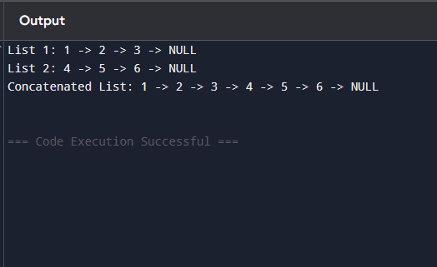
12. Write a program to perform the operations of the Double linked list:
- Insertion
- Deletion
- Display

#include <stdio.h>
#include <stdlib.h>

struct Node {
int data;
struct Node* prev;
struct Node* next;
};

struct Node* head = NULL;

// Insert at end
void insert(int data) {
struct Node* newNode = (struct Node*)malloc(sizeof(struct Node));
newNode->data = data;
newNode->next = NULL;
newNode->prev = NULL;

if (head == NULL) {
head = newNode;
return;
}

struct Node* temp = head;
while (temp->next != NULL) {
temp = temp->next;
}
temp->next = newNode;
newNode->prev = temp;
}

void delete(int key) {
struct Node* temp = head;

while (temp != NULL && temp->data != key) {
temp = temp->next;
}

if (temp == NULL) {
printf("Value %d not found.\n", key);
return;
}

if (temp->prev != NULL) {
temp->prev->next = temp->next;
} else {
head = temp->next; // deleting head
}

if (temp->next != NULL) {
temp->next->prev = temp->prev;
}

free(temp);
printf("Deleted %d\n", key);
}

void display() {
struct Node* temp = head;
printf("List: ");
while (temp != NULL) {
printf("%d <-> ", temp->data);
temp = temp->next;
}
printf("NULL\n");
}

int main() {
insert(10);
insert(20);
insert(30);

printf("After insertion:\n");
display();

delete(20);

printf("After deletion:\n");
display();

return 0;
}

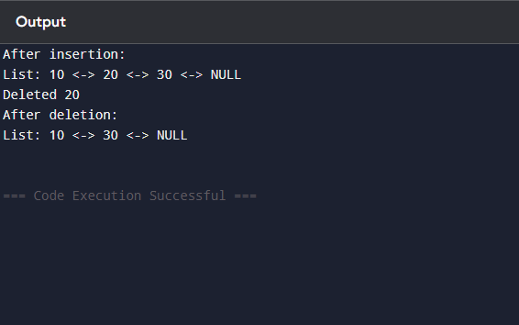
13 Write a program to perform tree traversal methods.

#include <stdio.h>
#include <stdlib.h>

// Define the node structure
struct Node {
int data;
struct Node* left;
struct Node* right;
};

// Function to create a new node
struct Node* createNode(int data) {
struct Node* newNode = (struct Node*)malloc(sizeof(struct Node));
newNode->data = data;
newNode->left = NULL;
newNode->right = NULL;
return newNode;
}

// Inorder Traversal (Left, Root, Right)
void inorder(struct Node* root) {
if (root != NULL) {
inorder(root->left);
printf("%d ", root->data);
inorder(root->right);
}
}

// Preorder Traversal (Root, Left, Right)
void preorder(struct Node* root) {
if (root != NULL) {
printf("%d ", root->data);
preorder(root->left);
preorder(root->right);
}
}

// Postorder Traversal (Left, Right, Root)
void postorder(struct Node* root) {
if (root != NULL) {
postorder(root->left);
postorder(root->right);
printf("%d ", root->data);
}
}

int main() {
// Create a simple binary tree
struct Node* root = createNode(1);
root->left = createNode(2);
root->right = createNode(3);
root->left->left = createNode(4);
root->left->right = createNode(5);

printf("Inorder Traversal: ");
inorder(root);
printf("\n");

printf("Preorder Traversal: ");
preorder(root);
printf("\n");

printf("Postorder Traversal: ");
postorder(root);
printf("\n");

return 0;
}

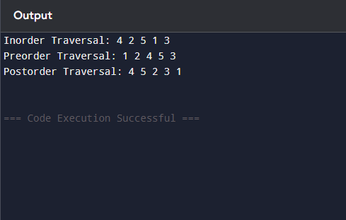

14. Write a program to perform insertion and deletion in the Binary Search Tree.
#include <stdio.h>
#include <stdlib.h>
struct Node {
int data;
struct Node* left;
struct Node* right;
};

struct Node* createNode(int data) {
struct Node* newNode = (struct Node*)malloc(sizeof(struct Node));
newNode->data = data;
newNode->left = NULL;
newNode->right = NULL;
return newNode;
}
struct Node* insert(struct Node* root, int data) {
if (root == NULL) {
return createNode(data);
}
if (data < root->data) {
root->left = insert(root->left, data);
} else if (data > root->data) {
root->right = insert(root->right, data);
}
return root;
}

struct Node* findMin(struct Node* root) {
while (root->left != NULL) {
root = root->left;
}
return root;
}

struct Node* delete(struct Node* root, int key) {
if (root == NULL) return root;

if (key < root->data) {
root->left = delete(root->left, key);
} else if (key > root->data) {
root->right = delete(root->right, key);
} else {
if (root->left == NULL) {
struct Node* temp = root->right;
free(root);
return temp;
} else if (root->right == NULL) {
struct Node* temp = root->left;
free(root);
return temp;
}
struct Node* temp = findMin(root->right);
root->data = temp->data;
root->right = delete(root->right, temp->data);
}
return root;
}
void inorder(struct Node* root) {
if (root != NULL) {
inorder(root->left);
printf("%d ", root->data);
inorder(root->right);
}
}

int main() {
struct Node* root = NULL;

root = insert(root, 50);
root = insert(root, 30);
root = insert(root, 70);
root = insert(root, 20);
root = insert(root, 40);
root = insert(root, 60);
root = insert(root, 80);

printf("Inorder traversal after insertion: ");
inorder(root);
printf("\n");

root = delete(root, 20);
printf("Inorder traversal after deleting 20: ");
inorder(root);
printf("\n");

root = delete(root, 30);
printf("Inorder traversal after deleting 30: ");
inorder(root);
printf("\n");

root = delete(root, 50);
printf("Inorder traversal after deleting 50: ");
inorder(root);
printf("\n");

return 0;
}
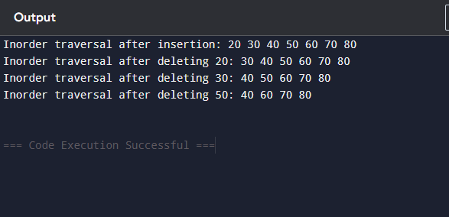

15. Write a program to represent an undirected graph using the adjacency matrix to implement the graph and perform the operations with menu-driven options for the following tasks: 1. Create graph 2. Insert an edge 3. Print Adjacency Matrix 4. List all vertices that are adjacent to a specified vertex. 6. Exit program

#include <stdio.h>
#include <stdlib.h>

#define MAX 10

int adj[MAX][MAX];
int n;

void createGraph(int vertices) {
n = vertices;
for (int i = 0; i < n; i++) {
for (int j = 0; j < n; j++) {
adj[i][j] = 0;
}
}
printf("Graph created with %d vertices.\n", n);
}
void insertEdge(int u, int v) {
if (u >= n || v >= n || u < 0 || v < 0) {
printf("Invalid vertices!\n");
return;
}
adj[u][v] = 1;
adj[v][u] = 1; // because undirected
printf("Edge inserted between %d and %d.\n", u, v);
}

void printMatrix() {
printf("Adjacency Matrix:\n");
for (int i = 0; i < n; i++) {
for (int j = 0; j < n; j++) {
printf("%d ", adj[i][j]);
}
printf("\n");
}
}

void listAdjacent(int v) {
if (v >= n || v < 0) {
printf("Invalid vertex!\n");
return;
}
printf("Vertices adjacent to %d: ", v);
for (int i = 0; i < n; i++) {
if (adj[v][i] == 1) {
printf("%d ", i);
}
}
printf("\n");
}

int main() {
int choice, vertices, u, v;

while (1) {
printf("\n--- Menu ---\n");
printf("1. Create Graph\n");
printf("2. Insert Edge\n");
printf("3. Print Adjacency Matrix\n");
printf("4. List Adjacent Vertices\n");
printf("5. Exit\n");
printf("Enter choice: ");
scanf("%d", &choice);

switch (choice) {
case 1:
printf("Enter number of vertices: ");
scanf("%d", &vertices);
createGraph(vertices);
break;
case 2:
printf("Enter edge (u v): ");
scanf("%d %d", &u, &v);
insertEdge(u, v);
break;
case 3:
printMatrix();
break;
case 4:
printf("Enter vertex: ");
scanf("%d", &v);
listAdjacent(v);
break;
case 5:
exit(0);
default:
printf("Invalid choice!\n");
}
}
return 0;
}

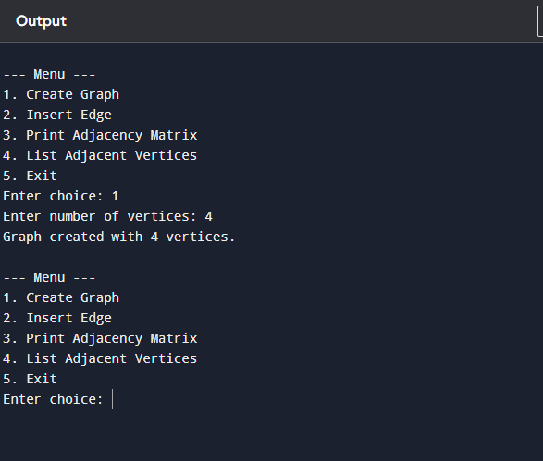

16. Kalnirnay: Conversion from Gregorian to Hindi calendar.
#include <stdio.h>

// Function to convert Gregorian month to Hindi month
const char* gregorianToHindi(int month) {
switch(month) {
case 3: return "Chaitra"; // March
case 4: return "Vaishakh"; // April
case 5: return "Jyeshtha"; // May
case 6: return "Ashadha"; // June
case 7: return "Shravan"; // July
case 8: return "Bhadrapad"; // August
case 9: return "Ashwin"; // September
case 10: return "Kartik"; // October
case 11: return "Margashirsha"; // November
case 12: return "Paush"; // December
case 1: return "Magh"; // January
case 2: return "Phalgun"; // February
default: return "Invalid month";
}
}

int main() {
int day, month, year;
printf("Enter Gregorian date (DD MM YYYY): ");
scanf("%d %d %d", &day, &month, &year);

const char* hindiMonth = gregorianToHindi(month);

// Convert year to Vikram Samvat and Saka Samvat
int vikramSamvat = year + 57;
int sakaSamvat = year - 78;

printf("\nGregorian Date: %02d-%02d-%d\n", day, month, year);
printf("Hindi Calendar Month: %s\n", hindiMonth);
printf("Vikram Samvat Year: %d\n", vikramSamvat);
printf("Saka Samvat Year: %d\n", sakaSamvat);

return 0;
}
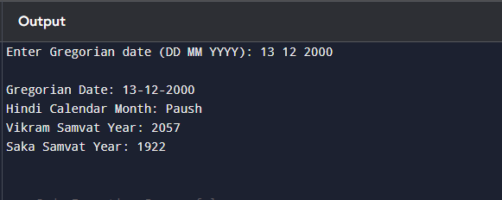

17.Create a basic system that recommends irrigation time based on soil type and crop, using linked lists to store crop data.

#include <stdio.h>
#include <stdlib.h>
#include <string.h>
struct Crop {
char cropName[30];
char soilType[30];
int irrigationTime; // in hours
struct Crop* next;
};
struct Crop* head = NULL;
struct Crop* createCrop(char cropName[], char soilType[], int irrigationTime) {
struct Crop* newCrop = (struct Crop*)malloc(sizeof(struct Crop));
strcpy(newCrop->cropName, cropName);
strcpy(newCrop->soilType, soilType);
newCrop->irrigationTime = irrigationTime;
newCrop->next = NULL;
return newCrop;
}
void insertCrop(char cropName[], char soilType[], int irrigationTime) {
struct Crop* newCrop = createCrop(cropName, soilType, irrigationTime);
if (head == NULL) {
head = newCrop;
} else {
struct Crop* temp = head;
while (temp->next != NULL) {
temp = temp->next;
}
temp->next = newCrop;
}
printf("Crop inserted successfully!\n");
}
void displayCrops() {
struct Crop* temp = head;
if (temp == NULL) {
printf("No crops available.\n");
return;
}
printf("\nCrop Data:\n");
while (temp != NULL) {
printf("Crop: %s | Soil: %s | Irrigation Time: %d hours\n",
temp->cropName, temp->soilType, temp->irrigationTime);
temp = temp->next;
}
}
void recommendIrrigation(char cropName[], char soilType[]) {
struct Crop* temp = head;
while (temp != NULL) {
if (strcmp(temp->cropName, cropName) == 0 &&
strcmp(temp->soilType, soilType) == 0) {
printf("Recommended irrigation time for %s in %s soil: %d hours\n",
cropName, soilType, temp->irrigationTime);
return;
}
temp = temp->next;
}
printf("No recommendation found for %s in %s soil.\n", cropName, soilType);
}

int main() {
int choice;
char cropName[30], soilType[30];
int irrigationTime;

while (1) {
printf("\n--- Irrigation Recommendation System ---\n");
printf("1. Insert Crop Data\n");
printf("2. Display All Crops\n");
printf("3. Recommend Irrigation Time\n");
printf("4. Exit\n");
printf("Enter choice: ");
scanf("%d", &choice);

switch (choice) {
case 1:
printf("Enter crop name: ");
scanf("%s", cropName);
printf("Enter soil type: ");
scanf("%s", soilType);
printf("Enter recommended irrigation time (hours): ");
scanf("%d", &irrigationTime);
insertCrop(cropName, soilType, irrigationTime);
break;
case 2:
displayCrops();
break;
case 3:
printf("Enter crop name: ");
scanf("%s", cropName);
printf("Enter soil type: ");
scanf("%s", soilType);
recommendIrrigation(cropName, soilType);
break;
case 4:
exit(0);
default:
printf("Invalid choice!\n");
}
}
return 0;
}
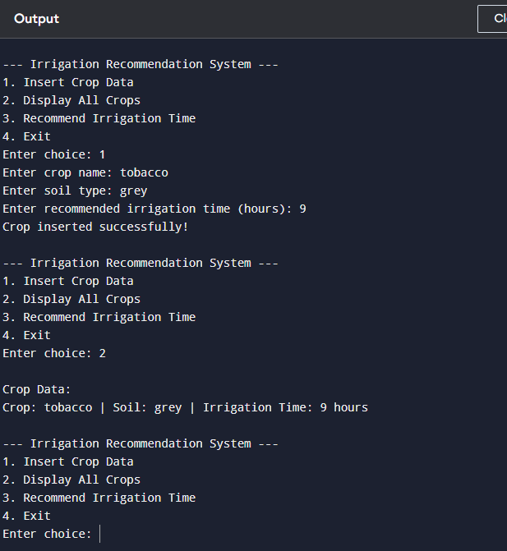

18. Design and implement a queue-based appointment management system for a clinic that handles patients in the order of their arrival. The system should maintain a First-Come, First- Served (FCFS) queue for patients and provide options to add new patients, view the next patient to be treated, serve (remove) a patient once treated, and display the list of all waiting patients.

#include <stdio.h>
#include <stdlib.h>
#include <string.h>
struct Patient {
char name[30];
int age;
struct Patient* next;
};
struct Patient* front = NULL;
struct Patient* rear = NULL;
void addPatient(char name[], int age) {
struct Patient* newPatient = (struct Patient*)malloc(sizeof(struct Patient));
strcpy(newPatient->name, name);
newPatient->age = age;
newPatient->next = NULL;

if (rear == NULL) {
front = rear = newPatient;
} else {
rear->next = newPatient;
rear = newPatient;
}
printf("Patient %s added successfully!\n", name);
}
void viewNextPatient() {
if (front == NULL) {
printf("No patients in the queue.\n");
return;
}
printf("Next patient: %s (Age: %d)\n", front->name, front->age);
}
void servePatient() {
if (front == NULL) {
printf("No patients to serve.\n");
return;
}
struct Patient* temp = front;
printf("Serving patient: %s (Age: %d)\n", temp->name, temp->age);
front = front->next;
if (front == NULL) {
rear = NULL;
}
free(temp);
}
void displayPatients() {
if (front == NULL) {
printf("No patients in the queue.\n");
return;
}
struct Patient* temp = front;
printf("Waiting patients:\n");
while (temp != NULL) {
printf("Name: %s | Age: %d\n", temp->name, temp->age);
temp = temp->next;
}
}

int main() {
int choice, age;
char name[30];

while (1) {
printf("\n--- Clinic Appointment System ---\n");
printf("1. Add New Patient\n");
printf("2. View Next Patient\n");
printf("3. Serve Patient\n");
printf("4. Display All Waiting Patients\n");
printf("5. Exit\n");
printf("Enter choice: ");
scanf("%d", &choice);

switch (choice) {
case 1:
printf("Enter patient name: ");
scanf("%s", name);
printf("Enter patient age: ");
scanf("%d", &age);
addPatient(name, age);
break;
case 2:
viewNextPatient();
break;
case 3:
servePatient();
break;
case 4:
displayPatients();
break;
case 5:
exit(0);
default:
printf("Invalid choice!\n");
}
}
return 0;
}
